**FACULTY OF SCIENCE AND TECHNOLOGY**

**Assignment (Laboratory) Coversheet**

|  |  |
| --- | --- |
| Student ID number | U3312590 |
| Student Name | Jasmine Bajracharya |
| Unit name | Introduction to Computer Engineering |
| Unit number | 10096 |
| Name of lecturer/tutor | Dr. Julio Romero |
| Assignment topic | HDL and Microprocessors |
| Due date | 2nd November, 2025 |
| Word Count | 1404 |

***You must keep a photocopy or electronic copy of your assignment.***

**Student declaration**

I certify that the attached assignment is my own work. Material drawn from other sources has been appropriately and fully acknowledged as to author/creator, source and other bibliographic details. Such referencing may need to meet unit-specific requirements as to format and style.

I give permission for my assignment to be copied, submitted and retained for the electronic checking of plagiarism.

**Date: 30th October 2025**

(Students submitting work electronically can type their name in the space for signature above, but

must produce a signed copy of this coversheet on request.)

**Date of submission: 30th October 2025**

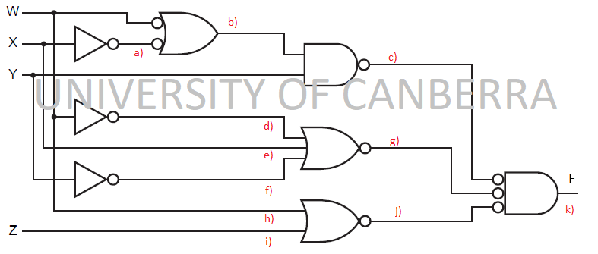

Figure 1: Boolean Circuit for Laboratory Week 12

# **1. Boolean Expression Derivation from Circuit (20 marks)**

Derive the Boolean expression that describes the circuit shown in Figure 1. Show your steps in each branch of the circuit given.

Here, we have for each intermediate expression we get,

# **2. Boolean Expression Simplification Using Theorems (10 marks)**

On simplification, the expression is given as:

# **3. Boolean Expression Simplification Using Karnaugh Maps (10 marks)**

The truth table for the above circuit is given as:

|  |  |  |  |  |
| --- | --- | --- | --- | --- |
| **W** | **X** | **Y** | **Z** | **F** |
| 0 | 0 | 0 | 0 | 0 |
| 0 | 0 | 0 | 1 | 0 |
| 0 | 0 | 1 | 0 | 0 |
| 0 | 0 | 1 | 1 | 1 |
| 0 | 1 | 0 | 0 | 0 |
| 0 | 1 | 0 | 1 | 0 |
| 0 | 1 | 1 | 0 | 0 |
| 0 | 1 | 1 | 1 | 1 |
| 1 | 0 | 0 | 0 | 0 |
| 1 | 0 | 0 | 1 | 0 |
| 1 | 0 | 1 | 0 | 0 |
| 1 | 0 | 1 | 1 | 0 |
| 1 | 1 | 0 | 0 | 0 |
| 1 | 1 | 0 | 1 | 0 |
| 1 | 1 | 1 | 0 | 1 |
| 1 | 1 | 1 | 1 | 1 |

Now, using Karnaugh map for the simplification of the expression, we get:

|  |  |  |  |  |
| --- | --- | --- | --- | --- |
|  |  |  |  |  |
|  | 0 | 0 | 1 | 0 |
|  | 0 | 0 | 1 | 0 |
|  | 0 | 0 | 1 | 1 |
|  | 0 | 0 | 0 | 0 |

On grouping the rows for 1’s we get:

The results from the simplification and Karnaugh map are different due to the redundancy in the terms in the manually simplified expression. The results are, however, equivalent.

# **4. VHDL Code representation SA (20 marks)**

From simplification obtained above, and using the structural approach, the code representation using structural approach is given as:  
  
considering , W -> IN1, X -> IN2, Y-> IN3, Z-> IN4 and F -> OUT

entity Logic is

port(IN1, IN2, IN3, IN4 : in bit; OUT5: out bit);

architecture LogicCircuit of Circuit is

component NOT_gate is

port(A:in bit;X:out bit);

end component NOT_GATE;

component AND_gate3 is

port(A, B,C: in bit; X:out bit);

end component AND_GATE;

component OR_gate3 is

port (A,B, C : in bit; X:out bit);

end component OR_GATE;

signal OUT1, OUT2, OUT3, OUT4: bit;

begin

G1: NOT_gate port map( A=>IN1, X=>OUT1);

G2: And_gate3 port map (A=>IN1, B=>IN2, C=>IN3, X=>OUT2)

G3: And_gate3 port map (A=>IN2, B=>IN3, C=>IN4, X=>OUT3)

G4: And_gate3 port map (A=>IN2, B=>OUT1, C=>IN4, X=>OUT4)

G5: OR_gate3 port map (A=> OUT2 , B=>OUT3, C=>OUT4, X=>OUT5)

end architecture LogicCircuit;

# **5. VHDL Code representation DF (20 marks)**

From simplification obtained above, using the Data Flow approach, we get the code as:

entity Logic is

port(

W: in STD_LOGIC;

X: in STD_LOGIC;

Y : in STD_LOGIC;

Z : in STD_LOGIC;

F : out STD_LOGIC;

);

End Logic;

Architecture Behavioral of Logic is

begin

F<= (W and X and Y) or (X and Y and Z) or (not W and Y and Z)

end Behavioral;

# **6. VHDL Implementation (20 marks)**

From simplification obtained above, and using the data flow approach,

**6.1** Correct structure of the code written in Vivado. It includes proper I/O mapping.

The code written in Vivado is as follows:

library IEEE;

use IEE.STD_LOGIC_1164.ALL;  
  
entity tute_12 is

port(

W: in STD_LOGIC;

X: in STD_LOGIC;

Y : in STD_LOGIC;

Z : in STD_LOGIC;

F : out STD_LOGIC;

);

End tute_12;

Architecture Behavioral of tute_12 is

begin

F<= (W and X and Y) or (X and Y and Z) or (not W and Y and Z)

end Behavioral;

Similarly, the testbench for the above is written as:

Library IEEE;

Use IEEE.STD_LOGIC_1164.ALL;

Entity tb_and_gate is

End tb_and_gate;

architecture behavior of tb_and_gate is

Signal A, B, Y; STD_LOGIC;

Begin

uut.entity work.tute_12

port map(

W => W,

X => X,

Y=> Y,

Z=>Z,

F=> F);

-- *Test process*

process

begin

W <= ‘0’ ; X <= ‘0’ ; Y <= ‘0’ ; Z<=’0’ wait for 10 ns;

W <= ‘0’ ; X <= ‘0’ ; Y <= ‘0’ ; Z<=’1’ wait for 10 ns;

W <= ‘0’ ; X <= ‘0’ ; Y <= ‘1’ ; Z<=’0’ wait for 10 ns;

W <= ‘0’ ; X <= ‘0’ ; Y <= ‘1’ ; Z<=’1’ wait for 10 ns;

W <= ‘0’ ; X <= ‘1’ ; Y <= ‘0’ ; Z<=’0’ wait for 10 ns;

W <= ‘0’ ; X <= ‘1’ ; Y <= ‘0’ ; Z<=’1’ wait for 10 ns;

W <= ‘0’ ; X <= ‘1’ ; Y <= ‘1’ ; Z<=’0’ wait for 10 ns;

W <= ‘0’ ; X <= ‘1’ ; Y <= ‘1’ ; Z<=’1’ wait for 10 ns;

W <= ‘1’ ; X <= ‘0’ ; Y <= ‘0’ ; Z<=’0’ wait for 10 ns;

W <= ‘1’ ; X <= ‘0’ ; Y <= ‘0’ ; Z<=’1’ wait for 10 ns;

W <= ‘1’ ; X <= ‘0’ ; Y <= ‘1’ ; Z<=’0’ wait for 10 ns;

W <= ‘1’ ; X <= ‘0’ ; Y <= ‘1’ ; Z<=’1’ wait for 10 ns;

W <= ‘1’ ; X <= ‘1’ ; Y <= ‘0’ ; Z<=’0’ wait for 10 ns;

W <= ‘1’ ; X <= ‘1’ ; Y <= ‘0’ ; Z<=’1’ wait for 10 ns;

W <= ‘1’ ; X <= ‘1’ ; Y <= ‘1’ ; Z<=’0’ wait for 10 ns;

W <= ‘1’ ; X <= ‘1’ ; Y <= ‘1’ ; Z<=’1’ wait for 10 ns;

Wait;

end process;

end behavior;

**6.2** Correct simulation of the circuit in Vivado (time diagram).

The circuit was simulated, and the timing diagram was obtained as:

*\*Note: The simulation video (timing diagram) can be accessed through the file timing_diagram_video/ timing_diagram.mp4*

**6.3** Correct functioning of the FPGA by verifying that your circuit works as intended using a truth table.

The truth table for the circuit is as follows:

|  |  |  |  |  |
| --- | --- | --- | --- | --- |
| **W** | **X** | **Y** | **Z** | **F** |
| 0 | 0 | 0 | 0 | 0 |
| 0 | 0 | 0 | 1 | 0 |
| 0 | 0 | 1 | 0 | 0 |
| 0 | 0 | 1 | 1 | 1 |
| 0 | 1 | 0 | 0 | 0 |
| 0 | 1 | 0 | 1 | 0 |
| 0 | 1 | 1 | 0 | 0 |
| 0 | 1 | 1 | 1 | 1 |
| 1 | 0 | 0 | 0 | 0 |
| 1 | 0 | 0 | 1 | 0 |
| 1 | 0 | 1 | 0 | 0 |
| 1 | 0 | 1 | 1 | 0 |
| 1 | 1 | 0 | 0 | 0 |
| 1 | 1 | 0 | 1 | 0 |
| 1 | 1 | 1 | 0 | 1 |
| 1 | 1 | 1 | 1 | 1 |

The FPGA implementation of the circuit is given as:

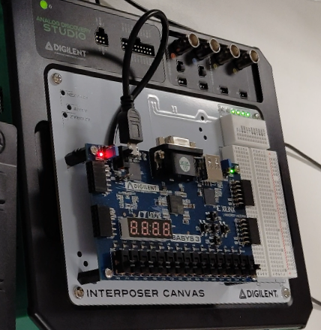  
  
*\*Note: The FPGA implementation can be accessed through the file : FPGA_video/ FPGA_implementation.mp4*

# **REFERENCES**

[1] Floyd, Th.L. Digital Fundamentals, Pearson, 2015

[2] Boolean algebra website: https://www.boolean-algebra.com